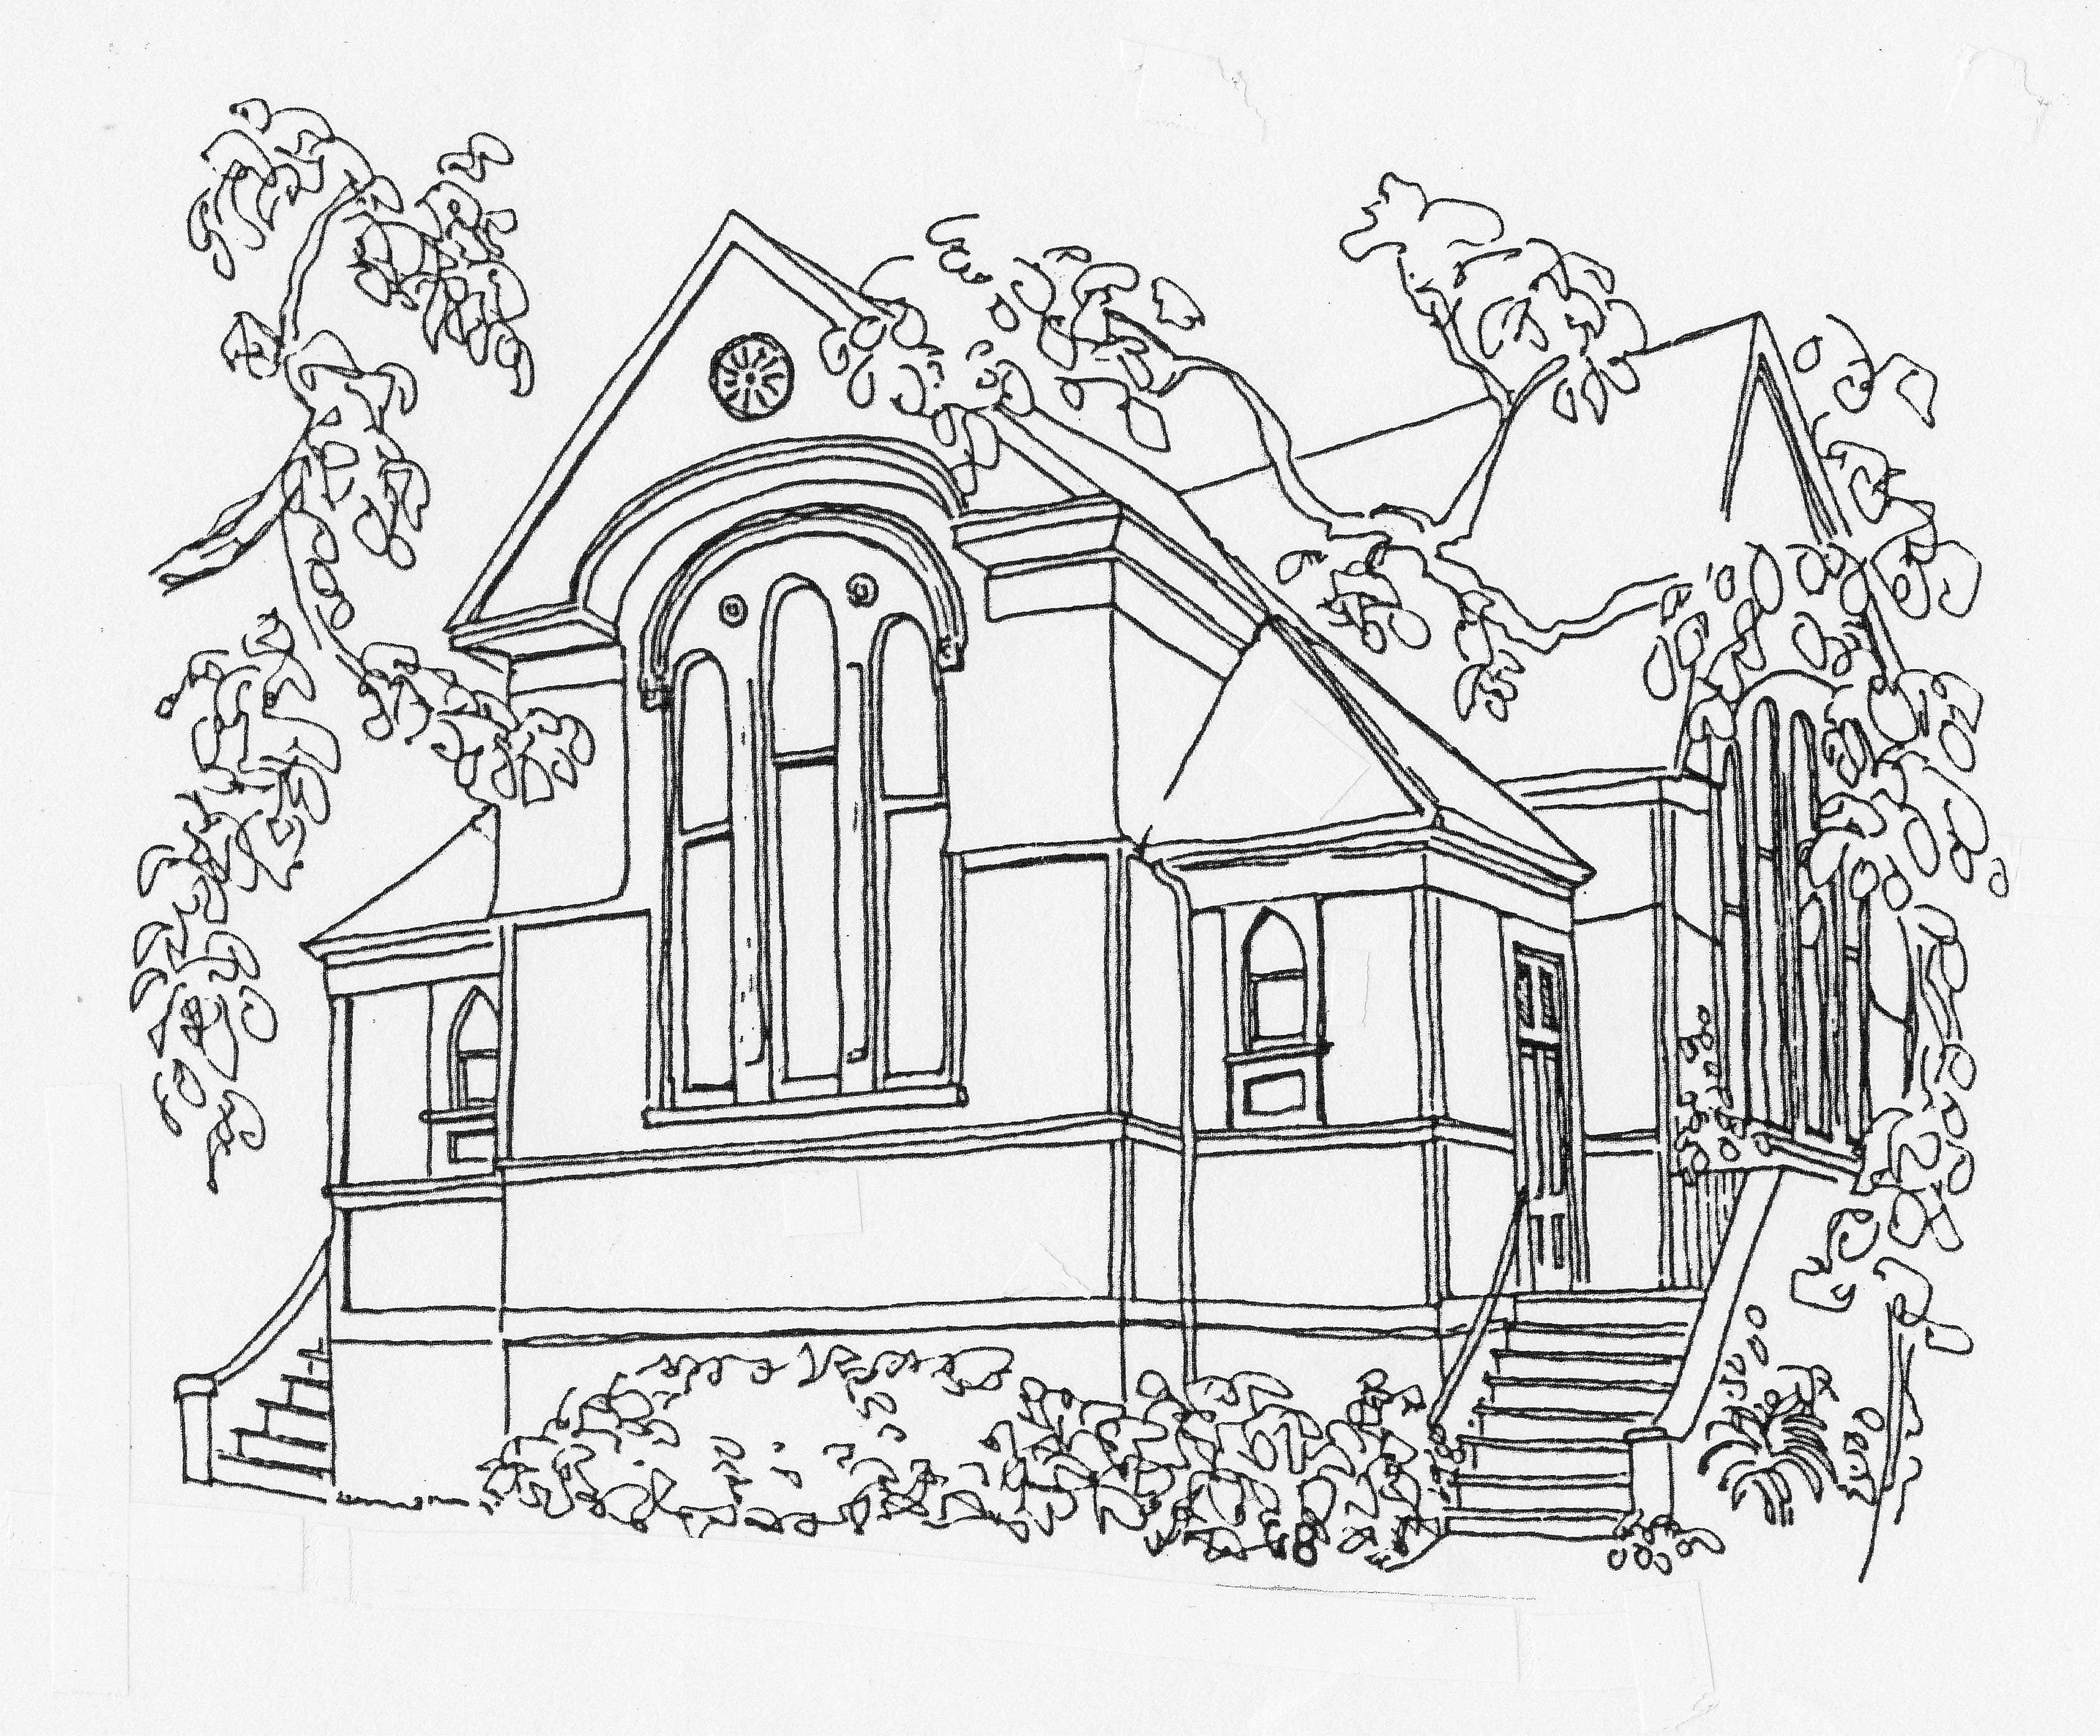
James Bay United Church
Single Use Rental Application
511 Michigan St, Victoria BC V8V 1S1
250-384-5821 jbuchurch@gmail.com

Name of group: _____________________________________________________ Key: ___________ # _______
Applicant’s name: ____________________________________________________________________________
Phone: _______________ Cell: ___________________ Email: _________________________________________
Alternate contact: ____________________________________________________________________________
Phone: _______________ Cell: ___________________ Email: _________________________________________
Nature of Event: ______________________________________________ Number of people expected: _______
Room(s): ____________________________________________________ @rate of: $ ______________________
Dates: ______________________________________________________________________________________
Times (include set-up and take-down): ____________________________________________________________
Equipment needed: _________________________ Tables: ______________ Chairs: _____________________
Will alcohol be served: ______ Name of person obtaining liquor licence: ________________________________
Kitchen Required: __________ Time Use: __________________________________________________________
Food Safe certificate holder(s) ___________________________________________________________________
Fee Summary:
Rooms required: _____________________________________________________________________________
Room rental fee: $___________ KEY DEPOSIT ($50) Ck. ____ Cash ____
Kitchen fee: $___________ Key deposit: Refunded_____ Destroyed _____
Total fees: $___________ Initials: _____________
I have read and will abide by the Terms and Conditions for Rental and Use of James Bay United Church facilities (see back)
Applicant’s signature: ________________________________________ Date of application: _________________
On behalf of James Bay United Church: ___________________________________________________________
For Emergency, you may contact: ________________________________________________________________
January 2017

